Stellar Designs
- Promo Items

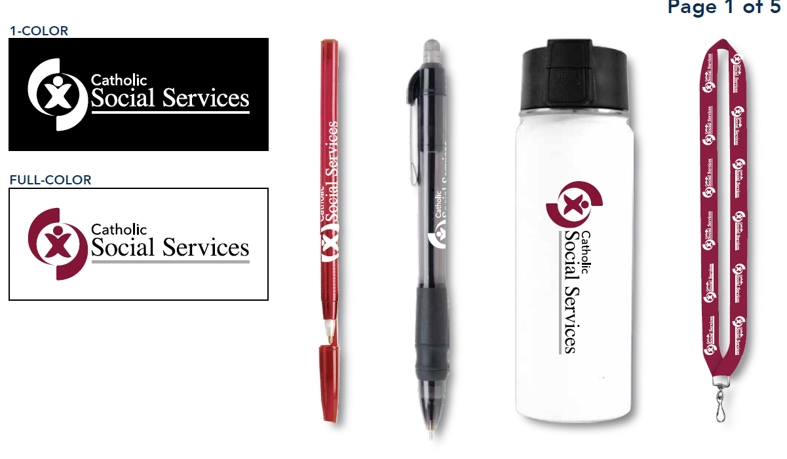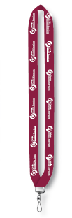
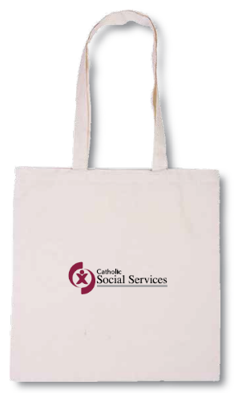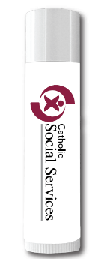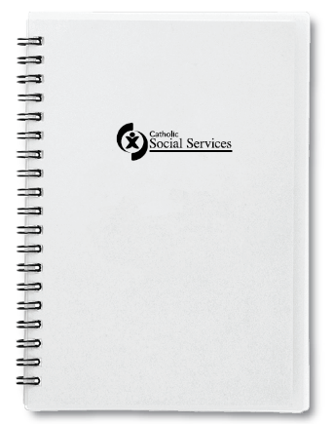

Item Price per unit
Stick pens (red with white logo) – | $0.35/ each
Click pens (black with white logo) - | $0.89/ each
Breakaway lanyard (maroon with white logo) | $2.93/ each
CSS canvas tote bag | $2.74/ each
Chapstick | $1.12/ each
Spiral 5” x 7” notebook | $2.68/ each

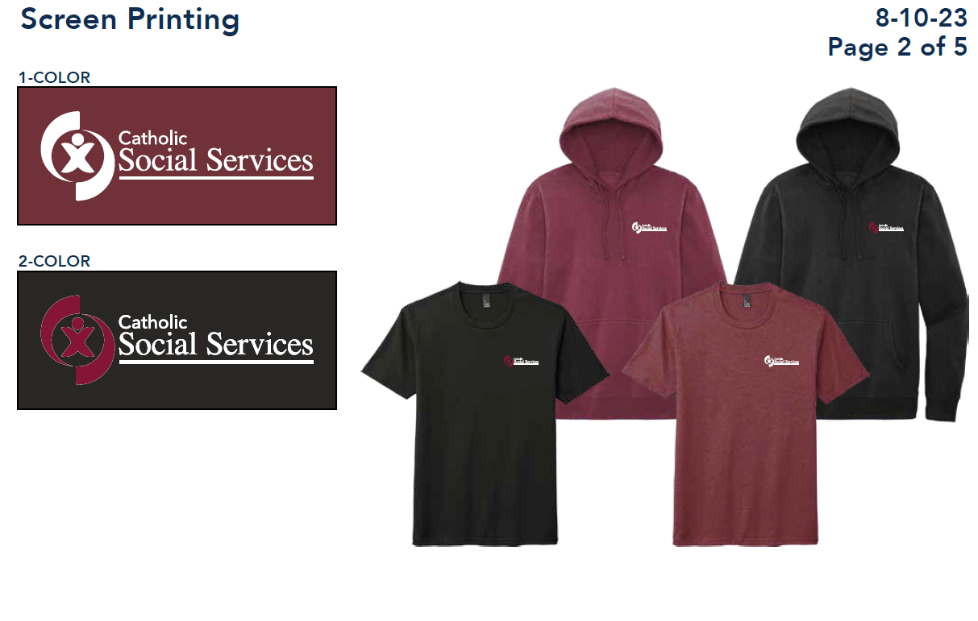
ITEM PRICE per unit
Maroon t-shirt (white logo) | $17.96/ each
Black t-shirt (white logo) | $21.92/ each
Maroon hoodie (white logo) | $31.96/ each
Black hoodie (white logo) | $35.92/ each

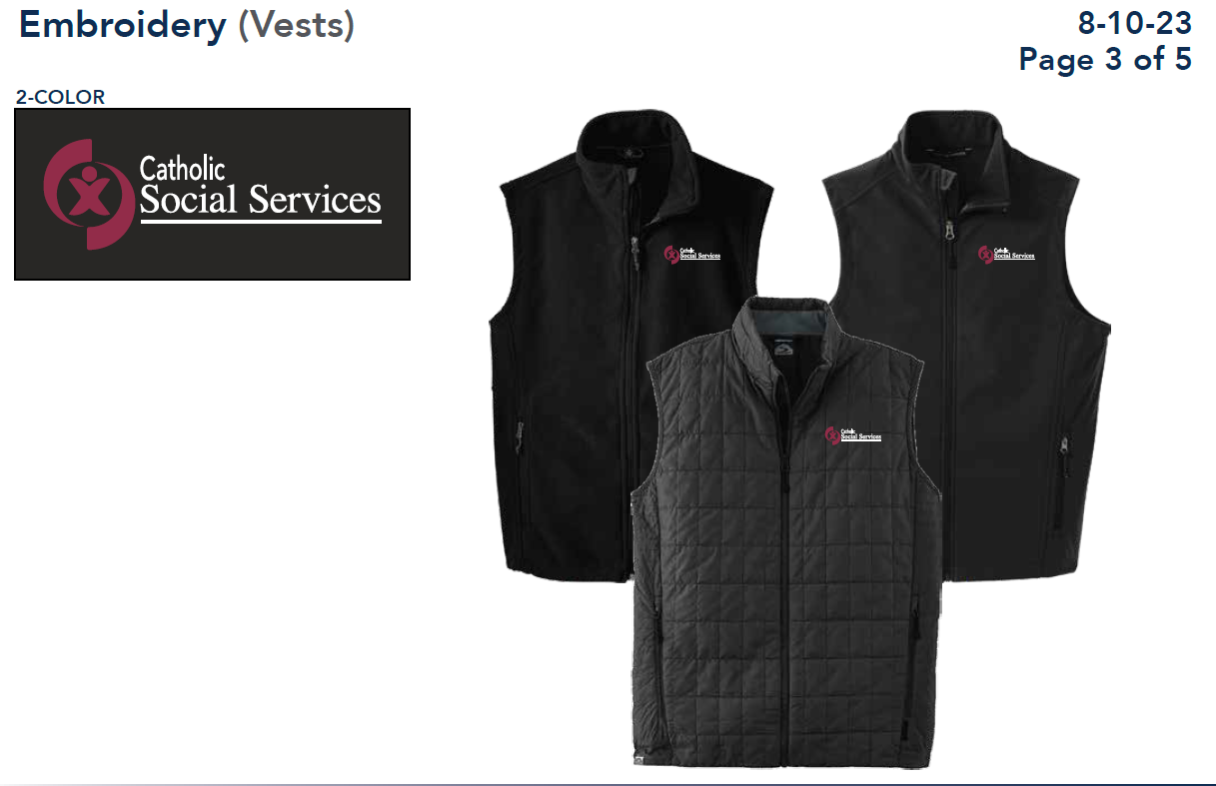
Item Price per unit
Black fleece embroidered vest | $43.89/ each
Black soft shell embroidered vest | $54.39/ each
Black puff vest | $76/ each

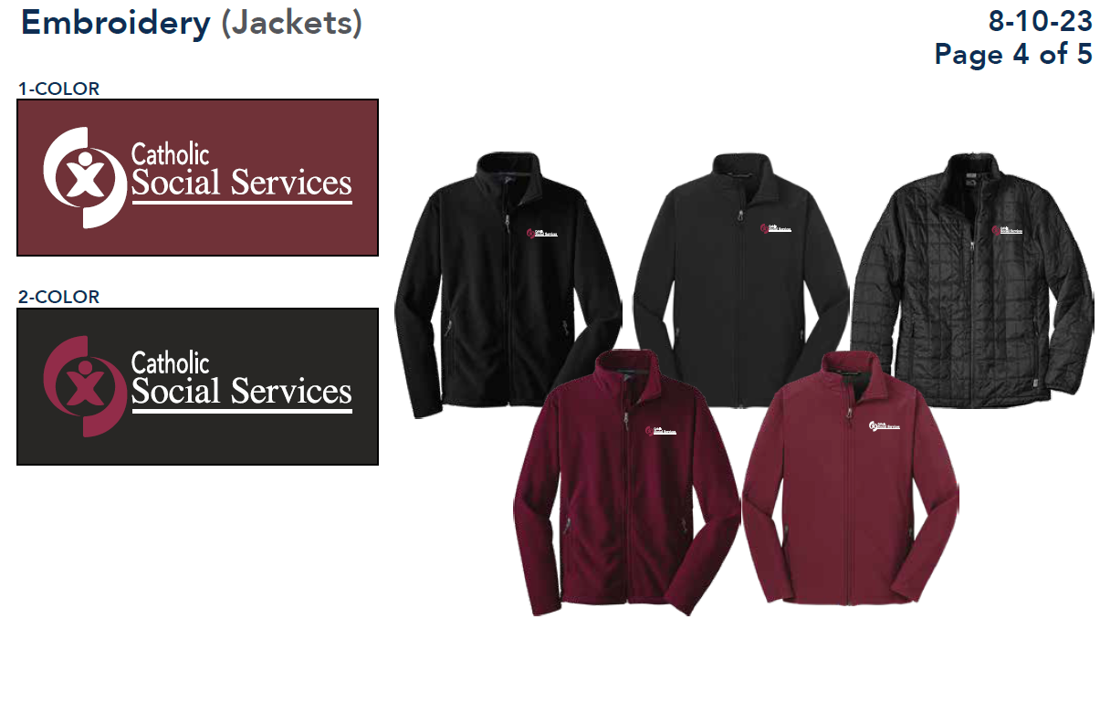
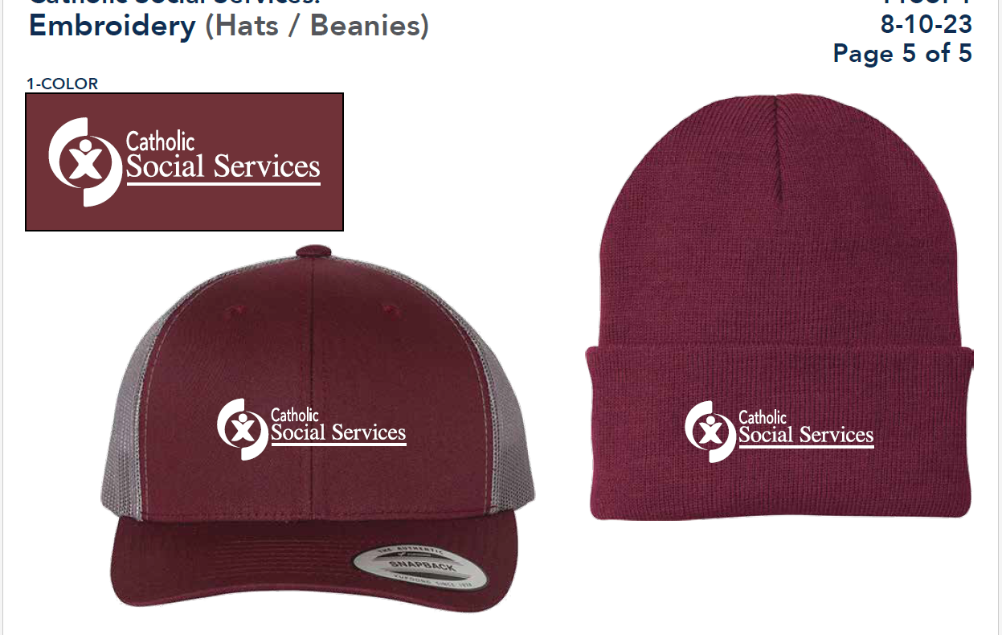

Item Price per unit
Maroon/Black fleece embroidered jacket | $44.25/ each
Maroon/black soft shell jacket | $52.75/ each
Black puff jacket | $103.75/ each
Trucker cap maroon | $16.50/ each
Beanie maroon | $16.25/ each

